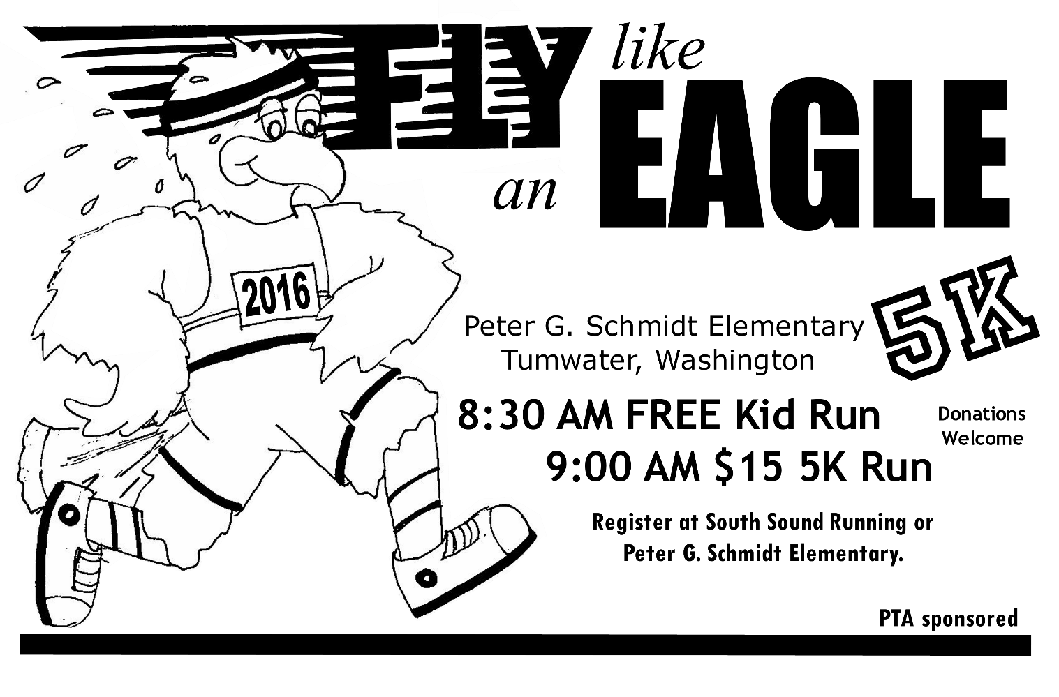
September 24, 2016
Name: _________________________________ Phone: ___________________________
Address: ________________________________ Gender: Male Female
Age on race day:____________________

A BENEFIT FOR PETER G. SCHMIDT ELEMENTARY SCHOOL
Registration
In store at South Sound Running 3405 Capitol Blvd.
--OR—
Mail to Peter G. Schmidt Elementary: 225 Dennis Str. Tumwater, WA 98501 until September 18th.
$15 registration, checks made to Peter G Schmidt Elementary
Day of registration begins at 8:00 am--$15 day of race registration
Packet pick-up morning of race beginning at 8:00 am
8:30 am Free Kids run—no registration necessary

Waiver: I know that running, regardless of the distance includes an element of risk. I should not participate in Fly like an Eagle 5k unless I am medically able and properly trained. I agree to abide by all rules of the road as defined by the Revised Code of Washington. I assume any and all risks associated with participating in group events including, but not limited to, illness, traveling to and from the group events, falls, contact with other participants, the effects of the weather (including temperature extremes and humidity) and the surfaces conditions of the roads and sidewalks, all such risks being understood and appreciated by me. Having read this waiver and knowing these facts, and in consideration of the acceptance of my application, I hereby for myself, my heir, executors, administrations or anyone else who might claim on my behalf, covenant not to use, and waive, release and discharge Peter G Schmidt, Tumwater School District, City of Tumwater its officers, agents and employees, event officials, volunteers and any and all other sponsors, suppliers, agents, independent contractors, employees and any other personnel in any way assisting or connected with group events from any and all claims or liability may arise out of negligence or carelessness on the part of the persons or parties named in the waiver. I also understand and agree that PGS, TSD, City of Tumwater may subsequently use, for publicly or promotional purpose, my name or picture of me participating in group events without liability or obligation to me. Application from minors will be accepted only with a parent or legal guardians’ signature.

I agree to sign the waiver and release ______________________________________________ (signature/date)
Parent/Guardian Signature (if under 18) ___________________________________________ (signature/date)

